Lab Exercise 9- Pagination, Filtering, and Sorting using Spring Boot Using IntelliJ IDEA Ultimate

1. Objective
To implement pagination, filtering, and sorting in a Spring Boot REST API using in-memory data structures, without using H2, MySQL, JPA, or Spring Data.

2. Software Requirements
• IntelliJ IDEA Ultimate Edition
• JDK 17 or 21
• Spring Boot 3.x
• Maven (bundled with IntelliJ)
• Browser / Bruno

3. Create Spring Boot Project in IntelliJ (IMPORTANT)
Step 3.1: Create New Project
- Open VS Code/ IntelliJ IDEA
- Click New Project
- Select Spring Boot
- Click Next

Step 3.2: Project Metadata
Fill the details exactly:
Project: Maven
Language: Java
Spring Boot: 3.x
Group: com.example
Artifact: paginationfiltersortnodb
Name: paginationfiltersortnodb
Packaging: Jar
Java Version: 17 (or 21)
Click Next

Step 3.3: Select Dependencies
Select only:
Spring Web

Click Create
IntelliJ will generate the project automatically.

4. Project Structure (Auto-Generated)
After creation, your project will look like:
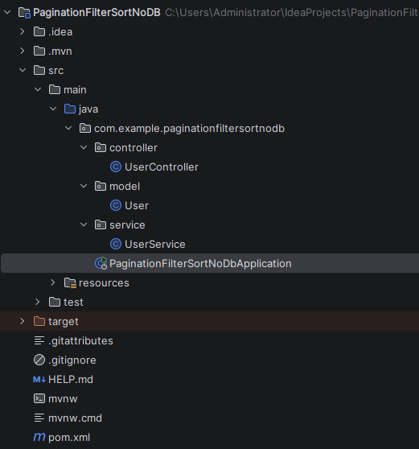

5. Create Model Class (User)
Step 5.1: Create Package
Right-click src/main/java/com/example/paginationfiltersortnodb

→ New → Package
→ model

Step 5.2: Create User.java
src/main/java/com/example/paginationfiltersortnodb/model/User.java
package com.example.paginationfiltersortnodb.model;

public class User {

private int id;
private String name;
private int age;

public User() {}

public User(int id, String name, int age) {
this.id = id;
this.name = name;
this.age = age;
}

public int getId() { return id; }
public void setId(int id) { this.id = id; }

public String getName() { return name; }
public void setName(String name) { this.name = name; }

public int getAge() { return age; }
public void setAge(int age) { this.age = age; }
}

6. Create Service Layer (In-Memory Storage)
Step 6.1: Create Package
Right-click com.example.paginationfiltersortnodb
→ New → Package
→ service

Step 6.2: Create UserService.java
src/main/java/com/example/demo/service/UserService.java
package com.example.paginationfiltersortnodb.service;

import com.example.paginationfiltersortnodb.model.User;
import org.springframework.stereotype.Service;

import java.util.ArrayList;
import java.util.List;

@Service
public class UserService {

private final List<User> users = new ArrayList<>();

public UserService() {
// Sample in-memory data
for (int i = 1; i <= 20; i++) {
users.add(new User(i, "User " + i, 20 + (i % 5)));
}
}

public List<User> getUsers() {
return users;
}
}

7. Create Controller (Pagination + Filtering + Sorting)
Step 7.1: Create Package
Right-click com.example.paginationfiltersortnodb
→ New → Package
→ controller

Step 7.2: Create UserController.java
src/main/java/com/example/paginationfiltersortnodb/controller/UserController.java
package com.example.paginationfiltersortnodb.controller;

import com.example.demo.model.User;
import paginationfiltersortnodb.service.UserService;
import org.springframework.web.bind.annotation.*;

import java.util.*;

@RestController
@RequestMapping("/users")
public class UserController {

private final UserService service;

public UserController(UserService service) {
this.service = service;
}

@GetMapping
public Map<String, Object> getUsers(
@RequestParam(defaultValue = "") String name,
@RequestParam(defaultValue = "0") int page,
@RequestParam(defaultValue = "5") int size,
@RequestParam(defaultValue = "id") String sortBy,
@RequestParam(defaultValue = "asc") String order
) {

List<User> users = new ArrayList<>(service.getUsers());

// Filtering
if (!name.isEmpty()) {
users.removeIf(u ->
!u.getName().toLowerCase().contains(name.toLowerCase()));
}

// Sorting
users.sort((a, b) -> {
Comparable v1 = getValue(a, sortBy);
Comparable v2 = getValue(b, sortBy);
return v1.compareTo(v2);
});

if (order.equalsIgnoreCase("desc")) {
Collections.reverse(users);
}

// Pagination
int total = users.size();
int start = page * size;
int end = Math.min(start + size, total);

List<User> paginatedList = new ArrayList<>();
if (start < total) {
paginatedList = users.subList(start, end);
}

// Response
Map<String, Object> response = new LinkedHashMap<>();
response.put("page", page);
response.put("size", size);
response.put("total", total);
response.put("data", paginatedList);

return response;
}

private Comparable getValue(User u, String sortBy) {
return switch (sortBy) {
case "name" -> u.getName();
case "age" -> u.getAge();
default -> u.getId();
};
}
}

8. Run the Application in IntelliJ
Step 8.1: Run Spring Boot App
- Open:
PaginationFilterSortNoDBApplication.java
- Click ▶ Run
You should see:
Tomcat started on port(s): 8080

9. Test API (Browser / Postman)
Base URL
http://localhost:8080/users

A. Pagination
GET /users?page=2&size=5

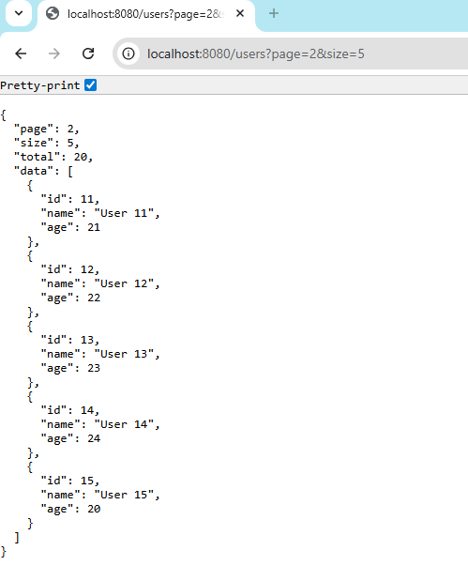

B. Filtering
GET /users?name=User 1

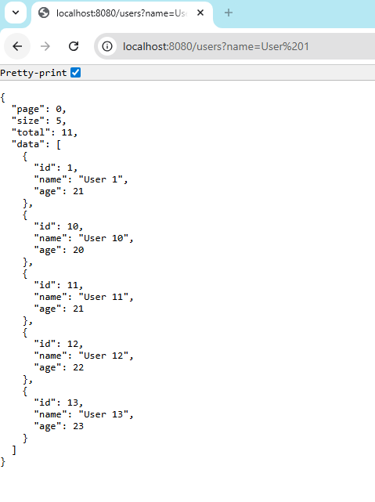

C. Sorting
Ascending:
GET /users?sortBy=age&order=asc

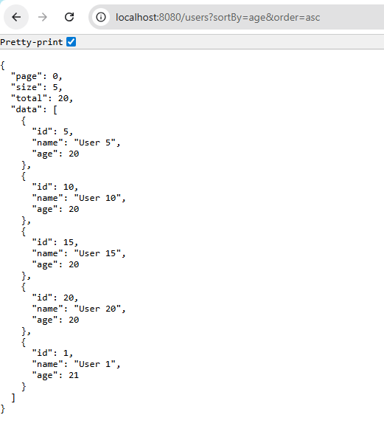
Descending:
GET /users?sortBy=name&order=desc

D. Combined Example
GET /users?name=User&sortBy=id&order=desc&page=0&size=3

